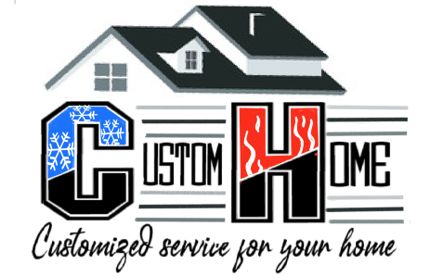 Custom Home Heating and Air

Heating and A/C Maintenance Agreement
Customer Care Advantages
- Maintain Efficiency of Furnace and Air Conditioner
- Extend Equipment Life
- Can Reduce Breakdowns as much as 95%
- 5% discount on Replacement of Furnace or A/C unit
- Transferable to your New Home
- We will call you to set up your Seasonal Maintenance
- 10% off Service Parts
- Priority Treatment for Service Calls
- No Overtime or Weekend Fees
- 1 year Warranty on Parts
ONE YEAR $199
Monthy Installment plan $20/month
Non Maintenance Agreement price $230

4556 N. 126th Street Butler, WI 53007 262-783-4328

